The pyramid of this assignment is designed to describe several communities, with some buildings and more families lived there, as: families > buildings > communities. The screenshot of pyramid:

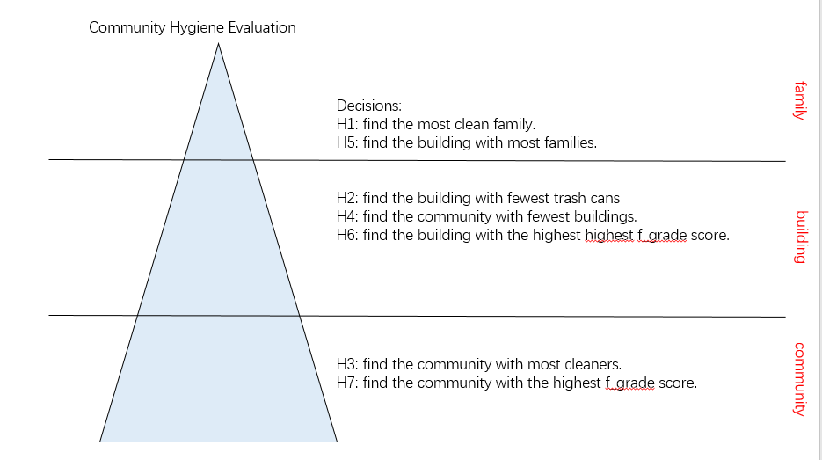

Map:

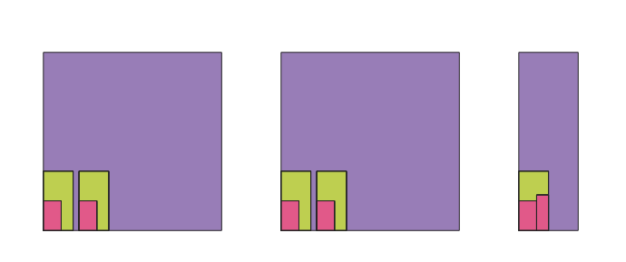

The three colors represent communities, buildings and families in order.